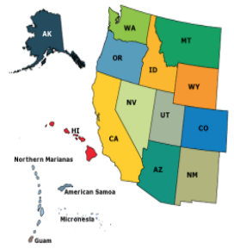
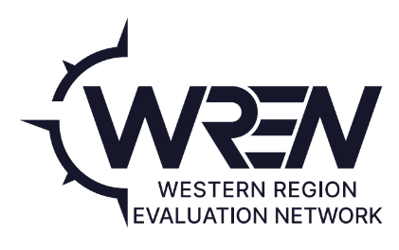
Western Region Evaluation Network (WREN)
WEDA Western Regional Evaluation
Network (WREN) Committee
January 1, 2024-December 31, 2024
Annual Plan of Work

Committee Mission/Purpose:
WREN is a network formed by the Western Program and Organizational Leadership Committee (WPOLC), which reports to the Western Extension Directors Association (WEDA). Our charge is to improve evaluation knowledge, skills, capacity etc. across the Western region. See our website “About” for more.

WREN Committee Members (Please list name and institution):
Committee Member | Institution
Alda Norris | University of Alaska Fairbanks
Daniel Helsham | American Samoa Community College
Madeleine deBlois | University of Arizona
Vikram Koundinya | University of California
Martha Thomas | Colorado State University
Kristina C. Sayama | University of Guam
Nancy Ooki | University of Hawai’i
Nav Ghimire | University of Idaho
Najat Elgeberi | University of Nevada
LaJoy R. Spears | New Mexico State University
Leanne Giordono | Oregon State University
Christina Sanders | Washington State University
Warren Crawford | University of Wyoming

Committee Membership & Mission/Purpose:

WREN is composed of professionals from each Western Extension Directors Association (WEDA) member institution who are able to represent the evaluation learning resources and needs of their institution. WREN currently has representatives from 13 Western states and territories. The group works to determine evaluation information and training needs across the region. WREN may organize activities by sub-committees based on member interest and expertise.
The full WREN committee meets at least annually with the Western Extension Directors Association and the Western Program and Organization Leaders Committee to review outcomes from past priorities and set goals for future work plans.

2023 Accomplishments:
(Please briefly describe the committee’s accomplishments this past year).

COMPETITIVELY SELECTED PRESENTATIONS
- Association for International Agricultural and Extension Education Conference, Guelph, Canada, April 26-29: Strategies to Face the Challenges of Evaluation Capacity Building When Working with Extension Professionals Not Trained in Evaluation

- National Epsilon Sigma Phi Extension Conference, Billings, September 25-28: Strategies to Maintain Evaluation Sustainability in High Turnover Work Environments

- American Evaluation Association Conference, Indianapolis, October 9-14: Strengthening Evaluation Practices Using a Regional Evaluation Capacity Building Model: Evaluation Through the Lens of the Western Regional Evaluation Network

- National Association of Extension Program & Staff Development Professionals Conference, Salt Lake City, November 28-30: Integrating Culturally Responsive and Racial Equity Approaches in Evaluation: Stories and Insights from Extension Practice in the Western Region

- Epsilon Sigma Phi Webinar, Zoom, December 4: Mixing Multiple Methods in Extension

- Extension Foundation, Workshop, Zoom, September 14, 2023:Crafting Insights: Mastering the Art of Survey Design

MEMBERSHIP EFFORTS
WREN networked to refill spots for Wyoming and American Samoa representatives and added a representative from the University of Hawaii to our membership. We also maintained an updated directory on the WREN website and shared the website at conference presentations.

WREN-connected resources have been used by California ANR to work with other states – including Washington – to improve impact reporting.

WREN members continue to share the WREN needs assessment annotated bibliography resource document with participants of the ongoing needs assessment training.

WREN’s major goals & ongoing strategies/activities:

Strategy/Activity | Metrics | Who | Timeline | Accomplishments
Rotating trainings (These trainings will be implemented by various WREN members for faculty and staff in multiple institutes in the Western Region based on the needs) | Acquire funding for rotation trainings | LaJoy Spears | Award announcement January 2024 | Proposal completed and submitted.
Continue to pursue outreach/representation from all of Western Region | Fill vacancies for:  1. Mariana Isles  2. Micronesia  3. Montana | Current WREN leadership | ongoing | Increased WREN institution membership by one during 2023
Publications and conference presentation efforts | Number of publications and conference presentations accepted during 2024 | WREN Members | During 2024 | Develop a list of conferences and Journals where publications and articles can be published.

Additional Priority Strategies/Activities and timeline for 2024:

Strategy/Activity | Metrics | Who | Timeline
Revisit outreach to 1994’s | increase 1994 institution membership | develop subcommittee? | Develop plan/timeline during in person meeting in March
Work with WEDA to initiate outreach to states/institutions not represented on WREN and/or in need of evaluation assistance | schedule and hold meeting with WEDA representatives | WREN committee | initiate communication in early Spring 2025
Revisit/define roles, responsibilities & expectations of WREN. Update subcommittees to include new WREN members. | new/updated documentation of roles/responsibilities and subcommittee assignments | WREN representatives - in person at WEDA/WPOLC spring meeting | March - April 2025

1994 Institutions in Western Region States:
Ilisagvik College-AK
Diné College - AZ
Tohono O'odham Community College - AZ
Aaniih Nakoda College - MT
Blackfeet Community College - MT
Chief Dull Knife College - MT
Fort Peck Community College - MT
Little Big Horn College - MT
Salish Kootenai College - MT
Stone Child College - MT
Institute of American Indian Arts - NM
Navajo Technical University - NM
Southwestern Indian Polytechnic Institute - NM
White Earth Tribal and Community College - MN
Northwest Indian College - WA

