The Western Water Network: A Vision for the Future of Water Management in the West

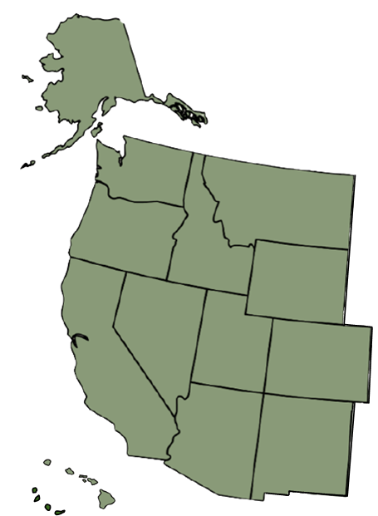
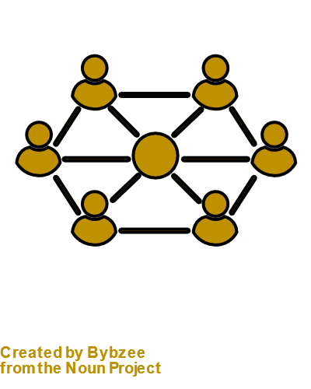
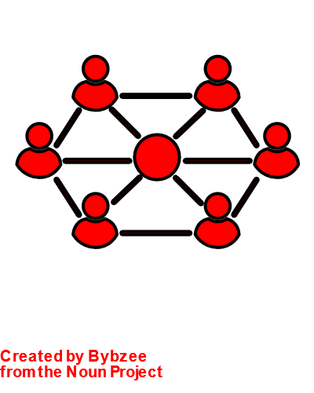
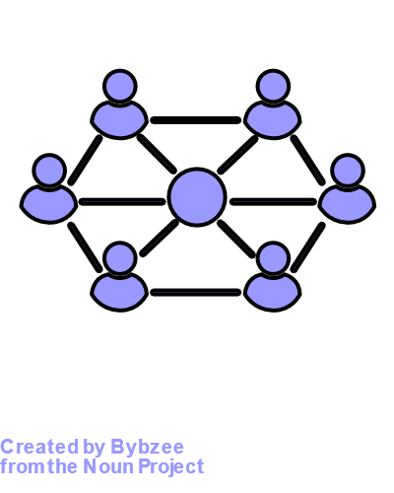
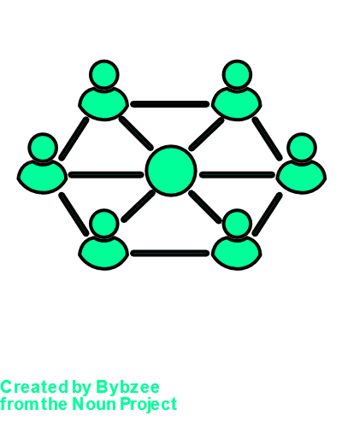
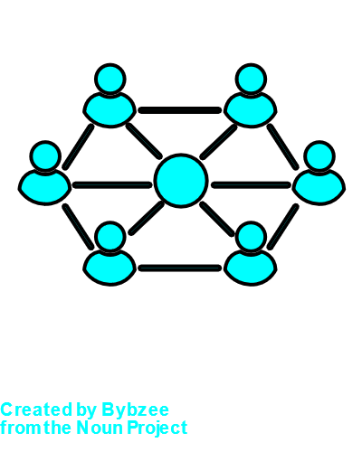
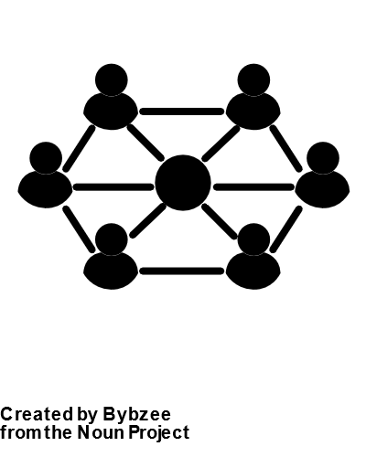
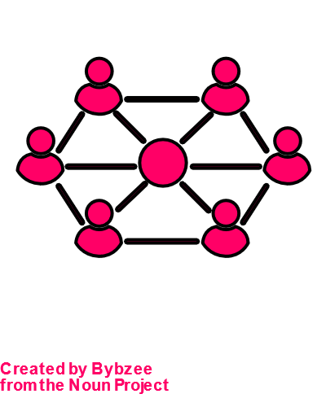
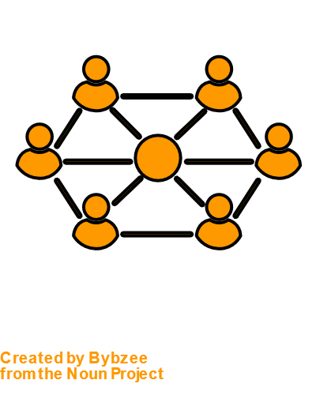
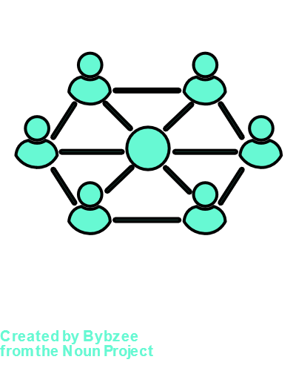
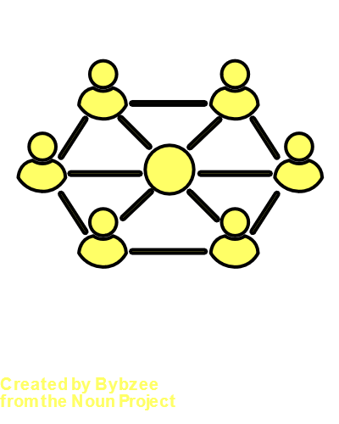

WW
Prepared by committees of The Western Water Network, a coalition of the Western Association of Agricultural Experiment Station Directors, Western Extension Directors Association, USDA WERAs, National Institutes for Water Resources, and Land Grant Universities of the Western United States.

EXECUTIVE SUMMARY

Changing Water in the West

Water is the lifeblood of the western United States. Yet increasing pressure on existing water supplies and changes in water availability—for both water quantity and quality—will only make management of water more important and more difficult in the future. Supplies are increasingly limited by drought and climate change, warming temperatures, increased evaporation, reduced streamflow, and depleted aquifers. Demand, meanwhile, is growing to meet the needs of growing populations and increasing water use for agriculture and communities. At its simplest, this boils down to managing water quality and quantity for ecosystem functions while providing water for human uses, including the need to resolve and incorporate sovereign tribal claims. The existing infrastructure and institutions in the West have not adapted to changing water realities.

Forming the Western Water Network to Promote Collaboration
The Western Association of Agricultural Experiment Station Directors convened a summit in 2020 to develop bold new approaches to confronting western water issues. Interested participants from different organizations tied to land-grant universities formed a loosely defined working group that distilled key findings. The group determined that there was a key unmet need to promote better and faster collaboration and knowledge exchange among water researchers, managers, educators, industry, and other stakeholders across state boundaries for improved understanding of water availability and management. For an early grant proposal to fund the effort, a name was chosen, and the Western Water Network (WWN) was born. The mission of the WWN is to advance collaborative, proactive, science-based water decision-making that supports dynamic human and natural systems in the West.

Building on the Strengths of the USDA WERAs and the Land-Grant Mission
A philosophy of applied and socially impactful research and Extension underlies the WWN. Many participants are leaders or members of U.S. Department of Agriculture (USDA) Western Multistate Research and Extension Projects (WERA) projects. These WERAs already assemble experts from across the West to address key topics related to water. The WWN brings these western research and extension efforts together to address complex water topics. Education is the third leg of the land-grant university mission supported by the WWN. The Western Water Network seeks to facilitate improved coordination, collaboration, and knowledge exchange in research, education, and engagement activities among western states, both within and across water basin boundaries. Consistent with the land-grant mission, in this vision paper we organize a basic structure for the WWN that centers around the land-grant pillars of research, Extension and education.

Building an Exciting and Effective Network for a Sustainable Western Water Future
This Vision Paper identifies opportunities for improved coordination, collaboration, and knowledge exchange among research and stakeholders across states. Stakeholders at the local level include the broad and diverse groups that form communities throughout the West, including farmers, ranchers, households, tribes, industries, and migrants. Researchers are at universities, agencies, and special topic organizations. The other key stakeholders are decision makers, policy makers, water managers, and other state and local leaders. The WWN provides inspiration and infrastructure to promote collaboration between researchers, Extension professionals, educators, and stakeholder collaborators to improve water security in the West. This Vision Paper offers an initial roadmap for the organization to establish itself and advance water security in the western United States, including Alaska, Hawaii, and the U.S. Territories.
AUTHORS

Kristiana Hansen  University of Wyoming  Dept. of Agricultural & Applied Economics and UW Extension | Brad Gaolach  Metropolitan Center for Applied Research & Extension, Washington State University Extension
Steven Buck  University of Kentucky Dept. of Agricultural Economics | Robert Heinse  University of Idaho Dept. of Soil and Water Systems
Derek Godwin  Oregon State University Dept. of Biological and Ecological Engineering and OSU Extension Service | Ginger Paige  University of Wyoming Dept. of Ecosystem Science & Management and UW Extension
Hope Braithwaite  Utah State University Dept. of Watershed Sciences | Travis Warziniack  USDA-USFS Rocky Mountain Research Station
Sam Fernald
New Mexico State University New Mexico Water Resources Research Institute

Disclaimer: The material contained in this document was conceived and written by many experts and compiled by the authors into one coherent document. We gratefully acknowledge the use of written materials by those experts.

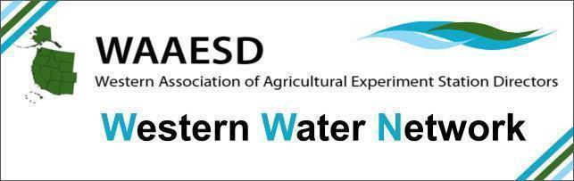
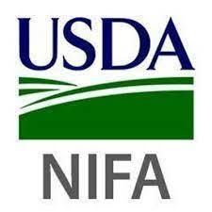
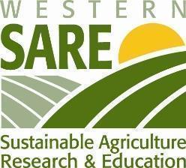

ACKNOWLEDGEMENTS: We are grateful to the Western Water Network Leadership Team and members for the input they provided at the 2022 Reno Assembly and the 2023 WWN Workshop. We are also grateful to UCOWR and the Western Association of Agricultural Experiment Station Directors (WAAESD) for support. This work is also sponsored by Western SARE and supported by conference grant no. 2022-12001 from the USDA National Institute of Food and Agriculture.

Equal Opportunity: Universities and Colleges in the Western Region do not discriminate on the basis of race, age, creed, color, religion, national origin or ancestry, sex, gender, disability, veteran status, genetic information, sexual orientation, gender identity or expression, or pregnancy. Western Region Universities and Colleges are equal opportunity/equal access/affirmative action employers fully committed to achieving a diverse workforce and complying with all Federal and respective State laws, regulations, and executive orders regarding non-discrimination and affirmative action.

Section 1. Water in the West & the Western Water Network

1.1 Water in the West

Water is scarce in the western United States (the West). Irrigated agriculture, human settlements, energy development, native fisheries and wildlife all place pressure on water resources in what are primarily arid and semi-arid environments. Even the Pacific Northwest, perceived as abundant with water, faces summer water shortages when water is needed most. And yet water’s sudden abundance in the form of stormwater runoff, winter flooding (from storm events, rain on snow events, rain on burn scars) and sea level rise can have devastating impacts on downstream water quality, ecosystems, and coastal communities. In the midst of these pressures, the need to resolve sovereign tribal claims on water resources persists. In no small part due to its scarcity and variability, water has significant economic, ecological, and social value to all who rely on it.

The challenges of managing water in the West are only growing. The growth of human population centers in arid portions of the Southwest, the intermountain west, and along the Pacific western corridor place more pressure on existing water supplies. Increases in temperature and changes in precipitation patterns and snowpack availability in the West are also changing water availability in ways that require irrigated agriculture, cities and towns, power supply companies, and fish and wildlife managers to adjust. These changes often result in conflict between competing water uses; when water availability changes, the rules and standard practices governing its allocation may no longer be adequate.

These challenges underscore the need for researchers, Extension professionals, and their stakeholder-practitioner partners to place additional focus on providing tools and information that help water managers make decisions in light of increasing demands and changes in projected water forecasts. Researchers and Extension professionals already engage in significant research and outreach focused on resolving water management challenges. However, current approaches are not enough when facing these levels of challenges that span political boundaries, diverse populations, cultures, and ecosystems, and conflicting demands. More needs to be done to facilitate coordination, collaboration, and knowledge exchange within and across water basin boundaries.

1.2 Western Water Network Background

In August 2020, the Western Association of Agricultural Experiment Station Directors (WAAESD) sponsored a virtual Mini Summit to develop a framework for identifying and addressing the most pressing water issues in the West. The Western Water Network (WWN) originated from this Mini Summit as a mechanism to help address current and coming challenges to water resources and management.

The WWN Leadership Team identified a key gap—the need to promote better and faster collaboration among water researchers, managers, educators, industry, and other stakeholders across state boundaries. In response, the WWN formed a USDA Rapid Response Multi-State Committee (W508: Western Water Network for Agriculture and Water Smart Communities: Responding to Climate Change and Other Stressors to Water Resources) to facilitate continued discussions.

In March 2022, the WWN Leadership Team convened the Reno Assembly (Reno, NV), whose purpose was to identify a path forward for the WWN towards the goal of improving western water security. The Assembly brought together water researchers and western water organizations to explore how to create effective collaboration on water management, policy, and sustainability. The Reno Assembly featured workshops to exchange views on the following:
- What are the most pressing water issues in the West that the WWN, as a region-wide network of state-specific networks could be poised to help address?
- What can the emerging WWN do that adds total capacity for everyone working on water security in the West?
- How to configure the WWN so that it effectively supports the work of existing organizations across the West?
Since March 2022, the WWN Leadership Team has been building on the ideas of the Reno Assembly participants to develop ways that the WWN can add value and capacity to existing organizations working on water security across the West. These efforts have led to the WWN’s first activities, a series of six organized sessions at the 2023 Annual UCOWR Meeting June 12-15, 2023 in Fort Collins, Colorado and the 2023 WWN Workshop immediately following on June 15-16, 2023 also in Fort Collins, Colorado. Collectively, these activities were a primary vehicle to gather momentum for the network and build its membership via research and knowledge exchange on pressing water issues. Specifically, these gatherings created a structured space to dig deeper into understanding current problems, barriers, and opportunities, and chart an initial vision for land-grant focused research and engagement to address western U.S. water challenges for the next ten years. This document presents that initial vision and outlines what is needed for implementation.

1.3 Western Water Network

The Western Water Network (WWN) consists of researchers with expertise in water management (many with affiliations to an Agricultural Experiment Station), a Cooperative Extension Services network (Extension), and the networks of stakeholders/groups with whom land-grant professionals regularly collaborate and serve. The WWN is thus a “network of networks” that aims to connect the broad, West-wide community of water researchers, Extension professionals, service providers, and policymakers tasked with confronting the most pressing water issues in the West.

The rationale for such a super-network is that water is many things to many people in the West, yet how water is managed for diverse ends in different parts of the West can and does affect the region as a whole. Further, even parts of the western U.S. region (such as Alaska, Hawaii, and the U.S. Territories) that do not share water resources are linked to the contiguous U.S. through federal law and policy and a shared history; knowledge exchange and transfer with these culturally and hydrologically diverse regions can strengthen our collective response to water management challenges. It is for these reasons that working together across the West can help stakeholders and groups effectively advance collaborative, proactive, science-based water decision-making on policy-relevant water management challenges in the West. In summary, the WWN seeks to facilitate improved coordination, collaboration, and knowledge exchange in water research, education, and engagement activities among western states, both within and, especially, across state boundaries.

There are, of course, many existing collaborative efforts that span disciplines, states, and researcher/Extension/stakeholder groups. Prime examples are regional and national trade organizations representing local and state governments and government agencies, such as Western Governors Association (and their affiliate, Western States Water Council), Council of State Governments West (with basin-focused forums such as the Colorado River Forum), the Interstate Council on Water Policy (ICWP), and the National Association of Counties and their affiliate Western Interstate Region caucus. Federal agencies such as the United States Army Corps of Engineers and the Bureau of Reclamation with their broader geographical scope also contribute to these discussions. Within universities, the National Institute of Water Resources (NIWR) facilitates collaboration, coordination, and knowledge exchange of their member water centers across state boundaries. Several USDA-sponsored multi-state committees facilitate collaborative research and Extension activities related to water management in the western U.S., and many USDA-AFRI grant funding programs explicitly encourage or require that grant proposal submissions demonstrate multi-institutional involvement. Many state Extension professionals have programming on water in their state, and there is national Extension programming on natural resource issues as well as impacts of climate change. The WWN seeks to support rather than supplant these existing efforts. Further, in spite of the outstanding existing efforts by these agencies, organizations, and entities, there are areas of regional capacity-building that would benefit from a different manner and vehicle of support. We envision the WWN as an entity that can assist research, education and engagement efforts related to regional water basin management in the West.

Competition for water, exacerbated by climate change, is altering patterns of water availability in the West. The agricultural sector, including researchers and Extension professionals, will be critical in addressing the challenges water users face in the region, because the agricultural sector is the primary water user in the western U.S. (Dieter et al. 2018). The three land-grant pillars of research, Extension, and education can build more connected communities – of water users, managers, researchers, and decision-makers. In sum, a regional network such as the WWN can create a framework to increase collaboration, coordination, and knowledge exchange across state boundaries, across academic disciplines, and between researchers and practitioners, for those working on transboundary water issues. It will improve engagement of university and agency researchers and partners, leading to more effective, efficient, and impactful research, education, and engagement. The WWN would help remove barriers limiting innovative solutions that require non-traditional collaborations; offer a space for reconsideration of inert aspects within our institutions and policy processes that prohibit progress; and seek new incentives and award systems that encourage and recognize the value of multi-actor approaches for their overall impact on water challenges rather than accomplishments of individual actors.

Section 2. Defining the Purpose and Focus of the Western Water Network

The basic structure and initial roadmap are devised with consideration of feedback regarding six areas of pressing need for water in the West. These six thematic areas were identified by the WWN organizing committee based on the 2022 Reno Assembly and proposed for special topic sessions at the 2023 UCOWR Annual Meeting that directly preceded the WWN Workshop in Fort Collins, Colorado. The six thematic areas are as follows:

• Increasing Diversity, Equity, and Inclusion (DEI) in western water management
• Interstate Collaboration and Barriers to Transboundary Water Management
• Hydrologic Processes and Human Water Systems
• Planning for a Future with Uncertain Climate
• Valuing Environmental and Human Health Benefits in Water Management
• Addressing Educational Gaps in Water Management

The first of these areas, increasing DEI, was recognized as important to all facets of western water management, as diverse voices have not always been heard in water management conversations. In response to the historical and continued current under-representation of tribes and other marginalized populations in water management, WWN Workshop participants integrated themes of diversity, equity, and inclusion throughout workshop discussions.

The 2023 WWN Workshop participants joined breakout sessions centered around the remaining five thematic areas. Breakout session discussions focused on knowledge and policy gaps that should be closed to improve water security in the West. While the flavor of each discussion varied by thematic area, the essence of the discussion was similar across groups and sorted naturally into the three land-grant institution pillars of research, Extension, and education (see Figure 1). Key points raised are summarized below.

2.1 Research

Workshop participants emphasized time and again the need to extend research study areas along appropriate river basin boundaries that cross state lines. Some outstanding water management research topics are inherently transboundary and would benefit from increased facilitation of interstate and interdisciplinary collaboration. Several examples follow.
- Natural and Human System Water Sustainability. The inextricably linked human systems that impact water systems require measurement and modeling of social, economic, and cultural drivers alongside hydrologic and biophysical factors in integrated models at community to basin wide scales.
- River and Basin Compact Analysis. Some river and basin Compacts are more flexible and adaptable to increased pressure on water resources and changing water conditions than others. Developing indices and metrics for identifying which Compacts are more or less flexible and adaptable for future success would be useful. Political and socio-economic feasibility are considerations in any evaluation of the need for incremental versus transformative change in basin water management and governance. What similarities and differences exist in water management and governance across basins?

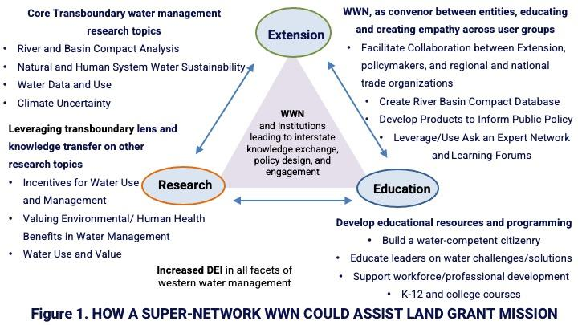

- Water Data and Use. Improved collaboration on standardized data collection is needed across state borders. Innovative examples that WWN could build on and use to inform trans-boundary efforts are OpenET (satellite-based remote system for consumptive use in agriculture), the Internet of Water Coalition (documenting efforts in California, New Mexico, and elsewhere to develop open water data laws), and the Columbia River Basin ET Mapping Tool. Further, more public information available on water markets and banks is needed (price is the item not readily available).
- Climate Uncertainty. Climate change introduces increased uncertainty around temperature and precipitation levels, which present challenges for water management. New approaches are needed–whether statistical, collaborative with communities, or engineering in nature–to provide water managers with the best possible information for decision-making. Climate uncertainty affects, for example, agricultural producers deciding what to plant and how much to irrigate; local government agencies making small-scale infrastructure investment decisions and considering stormwater management and nature-based solutions; and federal agencies tasked with water management and allocation on a broad, regional scale. The latter in particular requires effective transboundary collaboration and communication.
- Jurisdictional Complexities Across State Boundaries. Other challenging water management issues become even trickier when multiple political jurisdictions are in play. Examples include understanding how drought affects water quality; research into connectivity of water in different uses; and differential effects of federal, state, and tribal policies on water use and aquifer withdrawal.

Other outstanding research questions are not inherently transboundary in nature, but are pressing water management research needs that would benefit from a transboundary lens, both for the perspective provided and the importance of knowledge transfer. Increased knowledge of experiences in one basin helps resolve management challenges and conflicts in others. Learning from international and domestic experiences—both positive and negative—of water managers from other basins can be useful and is not done often enough. Several areas in which a transboundary lens would be valuable follow.
- Incentives for Water Use and Management. More research is needed into understanding agency and sociopolitical power at each level of water use and water decision-making, including at the local (farm, municipality, industry), water district, basin, state, federal, and where appropriate, international levels. There is often a mismatch between incentives for water use and social objectives surrounding water use (for example, disincentives to innovate created by the current crop insurance structure). How do we change incentives most effectively (e.g., social norms versus regulation), to encourage appropriate or collaborative water use and conservation?
- Water Use and Value. Many water challenges are at the interface of water availability and use, especially understanding spatial and temporal interactions in water use (e.g., conjunctive use of groundwater and surface water). We need a better understanding of water use, across sectors, time, and geography. We also need a better understanding of the value—cultural, economic, social—received from water use, and of why we use water in the first place. How much water do we need, both in human and natural uses? At issue here are ecosystem services, infrastructure, and cultural values.
- Valuing Environmental and Human Health Benefits in Water Management. As we increasingly recognize the importance of ecosystems to society and the harm that can occur to human health through damage to natural systems, it becomes even more important to understand the relationships between ecosystem conditions and services in response to climate and socioeconomic change. New research in this area takes a natural capital approach by developing methods for constructing asset accounts for ecosystem services using changes in land use projections associated with climate and socioeconomic change.
2.2 Extension
WWN will support the development of educational resources and programming that support building a water-competent civic citizenry. Additionally, it supports collaboration between Extension, policymakers, and their regional and national trade organizations that support them to educate future and current leaders on water challenges and possible solutions. WWN can be a convenor between entities, educating and creating empathy among and across user groups. WWN can help incorporate tribal perspectives into public discourse and decision-making (ideally tribal members themselves will provide this perspective).

The following are several Extension and other engagement activities that WWN could undertake to further deepen and expand knowledge transfer across and within basins.
- River and Basin Compact Database. ICWP maintains an inventory of interstate compacts. WWN could partner with ICWP to expand this inventory to include metrics by which to evaluate current Compacts in terms of their political, economic, and social sustainability, especially in light of increasing pressure on water supplies and changing water conditions. WWN could provide a resource on Compacts (again with ICWP and CSWG because both seek to do the same thing for their own members).
- Learning Forums. WWN could partner with ICWP, Council of State Governments West (CSGW), tribes, and organizations representing marginalized and under-served communities to create forums for “learning” and knowledge sharing. These forums could be a place for sharing information, stories, and experiences across basins and cultures. ICWP and CSGW would be valuable partners in this task because they seek to do the same thing for their own members. Collaboration between researchers, Extension professionals, industry, BIPOC-representing organizations, and policymakers would be powerful combinations in this endeavor.
- Products to inform public policy. WWN could provide consistent messaging on transboundary water issues/water management challenges (i.e., key talking points) for its members/states who have neither the time nor the bandwidth to focus. WWN could also create Data Visualization tools that are digestible and useful to the public and policymakers and use them to share information (compacts, issues, lessons learned) via forums, reports, etc.
- Ask an Expert. Appropriately resourced, WWN could serve as a clearinghouse for matching experts with those in need of information, knowledge, and resources. A model for this is the ticket system employed by some water centers and state Extension systems. This would be an incentive-based “ticket system” connecting experts to policy questions. Experts might be awarded with $200 for each response, or formally recognized by their institutions for answering stakeholder questions and increasing positive media and exposure for the university.
2.3 Education
Addressing educational gaps in water management. Are western water education and training programs sufficiently preparing the current and future workforce to meet water supply and quality challenges of a climate-changed water supply? Workforce development challenges in water management jobs and careers, and the solutions for addressing both professional development and capacity building, must consider unique agricultural, environmental, social, and economic ecosystems that exist in large, regional areas and watersheds crossing multiple states, such as the Pacific Northwest and Columbia River, and the Southwest and Colorado River. Examples of workforce needs that would benefit from regional collaboration, development, and sharing of technologies, education, and research efforts include the following.
- Professional Development. Workshop participants identified a need to “up-skill” people in the workforce through short, module-driven trainings that include certifications that have value and are marketable. Technology is creating new jobs and changing jobs. Workers need to be reached at all ages and skill levels throughout their career - young, mid-career, and late career, to address worker shortages at all skill levels throughout the water management fields. A specific example raised by WWN Workshop Participants is development of a water curriculum for policymakers, potentially developed in collaboration with ICWP and CSGW. CSGW currently provides continuing education courses for its newly elected officials. WWN could serve as a resource for these courses, towards the goal of building knowledge; tribal perspectives are extremely important for these continuing education courses.
- Recruitment. Market and recruit future agriculture workforce from people that haven’t experienced or grown up on a farm. Future workers will come from more urbanized areas than rural, farm-driven communities. They are more disconnected to agriculture and lack awareness of the wide diversity in agriculture job types. Jobs in agriculture have negative stigma (low-skilled, hard labor) and a history of discouraging pursuit of agriculture/farm careers, especially among Hispanic, indigenous/tribal, and other BIPOC families.
- Quality control. A variety of training opportunities exist from private industry, community colleges, and universities, but they are disconnected and unorganized, rather than coordinated. Certifications, badges, etc., are not consistent in terms of training, recognition, and value across training providers, industry, and employers. People are not seeking traditional credit degree programs that are accredited by professional associations.
- Create Educational Content for K-12 and College Courses. Workshop participants identified systemic shortcomings in general knowledge regarding water and recommended earlier intervention to remedy the situation. WWN could create open-access educational resources for the classroom. Potential examples include creation of a resource on groundwater regulations and how they work; a core course on water and the hydrologic cycle that establishes a foundational grounding in water and applying the latest technology in environmental sensors to help manage water use.
Many training concepts and tools already in existence within individual states are similar enough to be shared with neighboring states, but existing incentive structures encourage the individuals responsible for creating these materials to focus on their own state and traditional audiences. The WWN can help build the state Extension model across states in the water management space. Just as the WWN can facilitate collaborative and transboundary research efforts and share success stories across basins, the WWN can facilitate transfer of education/training programs across state boundaries. What is needed are incentives to participate, such as honorariums, awards and recognition for team projects with high-impact, and fewer barriers to collaborate across state boundaries, such as lower conference fees, travel funds, and project funding.
Section 3. Developing a roadmap: What is needed to sustain WWN and to continue its success?
Moving forward, the WWN seeks to support the next wave of innovations for water resiliency in the West; to explore the feasibility of innovative water management practices, policies, and institutions; to characterize, in collaboration with the USDA climate hubs, the patterns of water availability expressed as water budgets in the West; and to build teams of stakeholders and professionals to support decision-making and policy formulation for a secure water future in the West. Initial organizational structure and actions are required to achieve these ends. Section 2 provided examples of context in which WWN activity could impact water security in the West through the research, Extension and education pillars of the land-grant mission. This section defines some initial goals that can effectively bring the WWN to life (see Figure 2).

Partnerships Define an Active Network: WWN is seeking collaborative relationships with a wide range of researchers, Extension professionals and stakeholders, including industry, natural resource agencies, political leaders, tribes and other BIPOC-representing organizations, to engage in solving water related challenges. The WWN also recognizes that a network consists of the people who populate it; and that a successful network must possess sufficient resources, funding, and infrastructure to allow its members to grow and flourish if the WWN mission is to be accomplished. To initiate membership buy-in, a goal is to have researchers, Extension professionals, and stakeholders identify as affiliate members of the WWN in a searchable online directory.
Data-Sharing Between States: The WWN can help determine value and increase speed and efficiency of research as a hub that facilitates data-sharing with research partners, vendors, etc. To initiate a WWN data hub will require membership participation and expertise to establish, curate, and manage. One goal is to have members contribute data sources they have developed or used in their research and Extension activities and decision-making processes. A second goal is for WWN leadership to encourage Western states to contribute water-related data for transboundary research and Extension projects.
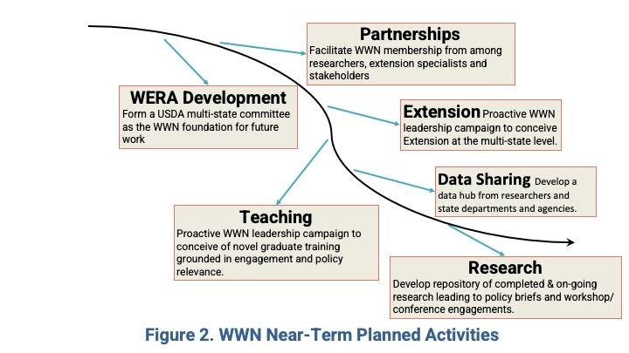

Research and Knowledge Transfer: High-quality, applied research is already conducted within universities and agencies and shared across states in the region. However, current institutional incentives support individual innovations and impacts over collaborative, transdisciplinary, and cross-cultural efforts that address larger societal issues and challenges related to water that cross state boundaries. The WWN can help streamline the process of building collaborative teams and connecting with stakeholders across boundaries, to help leverage ideas and focus efforts for more powerful impacts. This ultimately improves efficiency of the trans- and inter–disciplinary scientific processes, especially for newer faculty, and increases the likelihood of success in both research and knowledge transfer to address both local and regional needs. The WWN will connect with university leadership across the region to influence the development of awards, recognition, and incentives necessary to support this work and growth in participation. To initiate such collaborative research activities, there are multiple goals. One goal is to create a multi-disciplinary annotated repository of WWN members’ research, both completed and on-going. Another goal is to organize special sessions at conferences and other research meetings to combine (i) panel discussions, among senior faculty and policymakers/stakeholder leadership, and research presentations, from junior faculty and graduate students, with (ii) facilitated discussions to develop trans- and inter-disciplinary water projects.
Extension Conceived at the Multi-State Level: Extension professionals are stationed in communities across states with working relationships among local stakeholders and the people they serve. Unfortunately, higher-level, large-scale challenges related to water that cross multiple boundaries require more connections to experts in universities, industry, and other organizations than currently exist. Relying on internal university relationships to support community-based Extension professionals to address complex problems is too limiting and simply not working for addressing transboundary water issues in the West. The WWN can help connect Extension with experts in more disciplines and organizations to help engage in problem solving and future interdisciplinary research and technology development that would better help local communities. In return, Extension involvement can greatly enhance the WWN network among external stakeholders, such as industry, BIPOC communities, tribes, and political leaders, that is sometimes lacking among university researchers and leaders. To initiate an interstate Extension structure, we will target Extension professionals and related entities (relevant campus units, experiment station, and county faculty, stakeholders) for membership, and the WWN leadership will prioritize development funding activities among potential federal and non-federal funders to support Extension positions specializing in regional water management thematic areas of most pressing need: (i) Diversity, Equity and Inclusion, (ii) Institutions and Transboundary Water Management, (iii) Regional Hydrological Processes and Human Water Systems, (iv) Water Planning with an Uncertain Climate, (v) Environmental and Human Health Benefits of Water Management, and (vi) Regional Workforce Development.
Education Focused on Novel Modes of Graduate Training & Extension-based Professional Development: The WWN can support the regional capacity to train graduate students equipped to fill research and Extension positions. As an example, WWN can support efforts to devise an Extension Assistantship program, where graduate students work with Extension and research mentors to integrate regional water management into existing and emerging Extension programming. These work efforts will help Extension (i) offer better support for agricultural production and natural resource management, (ii) develop and offer trainings and resources to agricultural and natural resource professionals on how to incorporate climate change into their water resource programming, (iii) consider diversity, equity and inclusion throughout the graduate training process, and (iv) cultivate and build a network of regional Extension professionals (including researchers, staff, fellows and students) facilitating future collaborations. WWN can be a vehicle for research and Extension professionals to generate innovative models for institutionalizing Extension-relevant experiential training into academic graduate programs and to support the professional development of an Extension workforce that has the western water knowledge and expertise to comprehensively integrate pressing transboundary water management issues into Extension programs. We will target graduate student membership in WWN, to provide them with networking opportunities and to build their regional capacity. The WWN leadership will also prioritize development of funding activities to support graduate training programs such as the Extension Assistantship program described above. In addition, WWN can facilitate semester exchange programs between universities to receive visiting graduate student researchers working on pressing transboundary water issues.
The WWN is in the process of creating a new USDA National Institute of Food and Agriculture project intended to unite the many water-related multistate projects and convene a regular congress on water in the West, focused on collaborative fact-finding and cooperative solutions. Many of these next steps can be accomplished within the structure and partnerships developed as part of that process.

For Further Reading

For more background on the work done by the WWN prior to the WWN Workshop see, Proceedings from the Mini-Summit on Water Security in the Western US.: https://www.waaesd.org/wp-content/uploads/2022/01/Western-Water-Summit-Proceedings_09122020.pdf.

Talking Points describing the vision for the WWN: https://www.waaesd.org/wp-content/uploads/2022/01/WWN-Talking-Points-20220120.pdf.

Draft Rules of Operation for the WWN: https://www.waaesd.org/wp-content/uploads/2022/01/20211208-Western-Water-Network-Minutes.pdf.

Hansen, K. and R. Heinse. 2023. Water Resilience in Agriculture. In: Zhang, Q. (eds) Encyclopedia of Smart Agriculture Technologies. Springer, Cham. https://doi.org/10.1007/978-3-030-89123-7_192-3.

Warziniack, T., R. Heinse, A. Fernald, M. Gaffney, K. Hansen, B. Hess, L. Houglum, G. Paige, and Q. Zhang. 2023. “Western Water Network: A Case Study in Water Network Formation.” Journal of Contemporary Water Research and Education 178: 47-56. Available at
https://ucowr.org/wp-content/uploads/2023/08/178_Warziniak_et_al.pdf.

Appendix. Western Water Network Members and Other Contributors

Many individuals have contributed time, energy, expertise, and resources to development of the Western Water Network. The list below is not exhaustive but does indicate the depth and breadth of support for the WWN concept among water experts, Extension professionals, and practitioners.

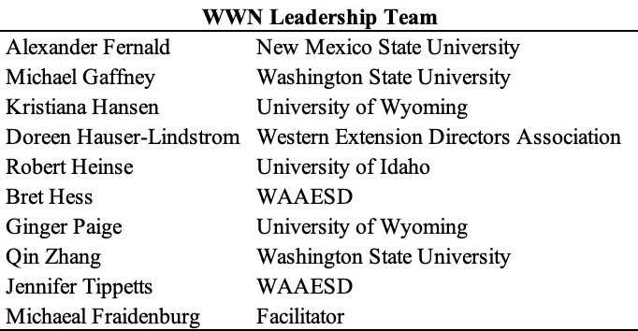

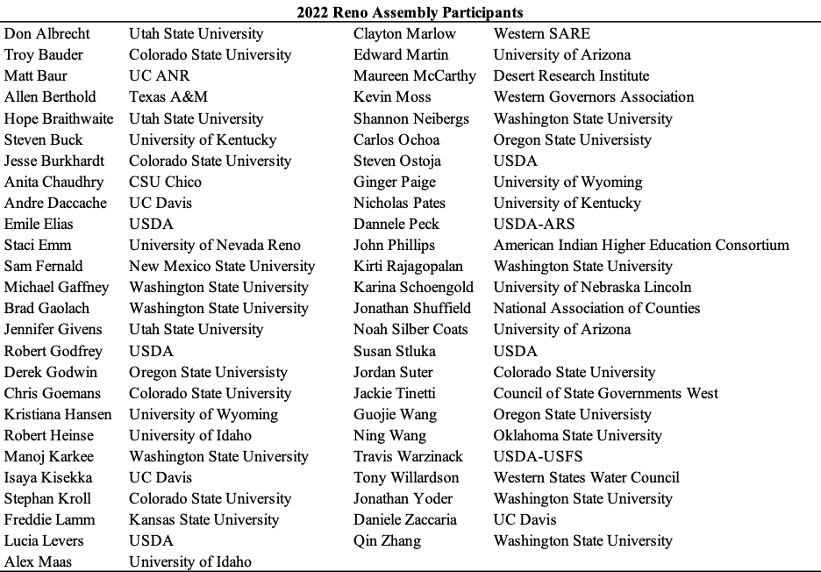

The Reno Assembly consisted of seven workshop discussion sessions, each seeded by questions around pressing water issues and/or how the WWN could add value. Please see the Reno Assembly Final Report for thoughts and impressions shared by participants at the Reno Assembly.
For example, WERA1014: Intensive Management of Irrigated Forages for Sustainable Livestock Production in the Western U.S; WERA1023: Watershed Processes and Human Water Systems; W3009: Integrated Systems Research and Development in Automation and Sensors for Sustainability of Specialty Crops; and W4190: Management and Policy Challenges in a Water-Scarce World.

